Day 1: A Sticky Situation

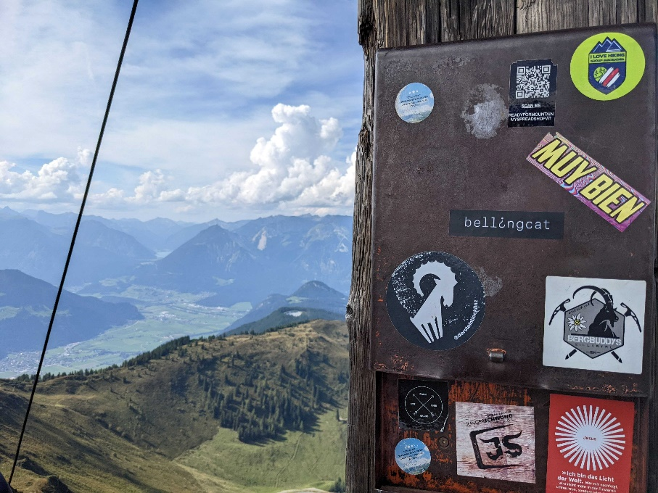

*In August of 2022, Bellingcat's Foeke Postma found himself looking over this beautiful view, complete with a Bellingcat sticker! But where was this enviable mountaineering adventure taking place?*

*What is the name of the mountain on which Foeke was standing?*

I started by doing a Google reverse image search. No exact matches are found. Let’s zoom into the stickers to see if we may find any clues about likely locations. The stickers are in different languages, although most are in German. Specifically, three stickers mention Tirol. So, it is very likely that the mountain is located in Tirol. Let’s go to Google Maps to get a feel for the size and terrain of this area. So apparently Tirol is a large area in Austria. Looking back at the results for the Google reverse image search, I see some crosses that seem similar to the wood and line visible in the picture. I’m not familiar with this phenomenon, but maybe it has a name. To find this out, I Google for: Austria cross mountain. The first result is a Wikipedia page on summit crosses, which in German are called a Gipfelkreuz. That may be what we’re looking for. Let’s see if we can find images that are similar to our image using the search: Tirol Gipfelkreuz. Now we have to find out the exact location. I hope to find out more clues from the picture. The mountains in the picture do not seem to have snow. This can be because of the season (August) or maybe the mountains are not very high. The mountain also does not seem to be above cloud level, although this is difficult to tell since there are no clouds directly above. We can see a small village in the valley between the mountains. There might even be a body of water in the distance, but I can not tell for sure. The shadows are pointing to the bottom-right in this picture, so the sun was coming from the upper-left. If we assume that the time that this picture was taken was about 15.00 (just a guess), then the sun was coming from the South-West, meaning that the orientation of the picture is to the West. The mountains seem to be darker than the valley, perhaps due to trees. Since the Tyrol area is so vast, I realized it is not feasible to go through satellite imagery to find the mountain. So, I decided to check on Discord how others approached this challenge. One user mentioned focusing on the Zillertal area, because one sticker mentions this area. I originally did not want to focus my search too much on specific locations found on the stickers, because people can always travel to different locations to climb a mountain. But for now, let’s go with this lead. Looking through the satellite images on Google Maps, I was trying to find a mountain with a small circular lake on it on the right side of the valley. I found one near Bruckerberg and Kerschbaumer that seemed very similar to the one in the picture. If we go with this perspective, we can see that the Achensee is probably the body of water that can be seen in the background of the picture. Now I continue to look at this location in Google Earth Pro, so I can try to replicate the perspective of the photo. Pretty quickly, I am able to get a very good reconstruction of the photo, see below. This perspective has the coordinates: 472211.83, 115435.14. Zooming out a little bit on this location, I see photos with the mention of Wiedersberger Horn. Let’s Google to see if we can find out more about this mountain, specifically it’s Gipfelkreuz. Although I am unable to see the stickers on the Gipfelkreuz, the wood does seem to match. So, our answer for this challenge is:

**Wiedersberger Horn**.

